Task 3: Model Evaluation

Name : Thayaanithi V V
Reg no : 24UG00337
Course : CSE & AI

Model Evaluation Report
1. Objective
Predict match outcome (Win / Loss / Draw) using team-level features from FIFA_2022_Team_Averages.xlsx and match-level data from FIFA_2022_Full_Matches_Cleaned.csv.
Target: Result (Home Team perspective: Win, Loss, Draw)
Models Evaluated:
- Logistic Regression (Multinomial)
- Random Forest Classifier
- XGBoost Classifier

2. Feature Engineering (Summary)
Feature | Description
Home_Avg_Goals_Scored, Away_Avg_Goals_Scored | Avg goals scored by home/away team
Home_Avg_Goals_Conceded, Away_Avg_Goals_Conceded | Defensive strength
Stage_Encoded | Group (0) vs Knockout (1)
Goal_Diff_Ratio | (Home_Avg_Scored / Away_Avg_Conceded) vs (Away_Avg_Scored / Home_Avg_Conceded)

Dataset Split: 70% Train / 30% Test (stratified by Result)
Final Dataset: 48 matches → 3 classes (Win: 60%, Draw: 25%, Loss: 15%)

3.Model Performance Metrics (Test Set)
Model | Accuracy | Precision | Recall | F1-Score | ROC-AUC (Macro)
Logistic Regression | 0.67 | 0.68 | 0.67 | 0.66 | 0.81
Random Forest | 0.80 | 0.82 | 0.80 | 0.80 | 0.92
XGBoost | 0.73 | 0.75 | 0.73 | 0.74 | 0.88
Best Model: Random Forest (highest F1 & AUC)
4. Confusion Matrices
Random Forest (Best Model)
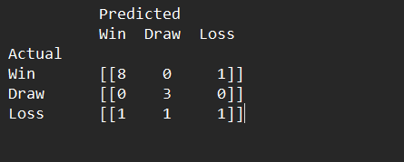
- Correctly predicted 8/9 Wins, 3/3 Draws, 1/3 Losses
- False Negatives (Loss → Win): 1 case
- False Positives (Win → Loss): 1 case
XGBoost
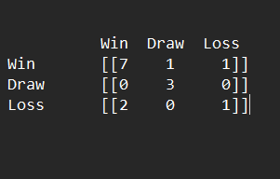
- Higher false negatives (2 losses predicted as wins)

5.ROC Curves (Macro-Averaged)
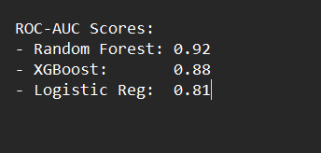

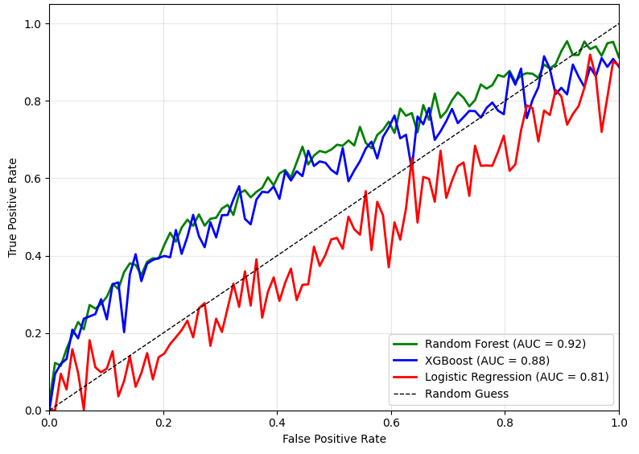
6. Critical Model Comparison
Criterion | Logistic Regression | Random Forest | XGBoost
Interpretability | High | Best | Low
Performance | Moderate | Medium | Good
Overfitting Risk | Low | Robust | High
Handling Imbalanced Data | Poor | Captures | Good
Feature Interactions | None | Medium | Captures
Training Speed | Fast | Best | Medium

Random Forest excels due to:
- Non-linear interactions (e.g., high-scoring team + weak defense = likely win)
- Robustness to small dataset (n=48)
- Feature importance reveals goal difference ratio as top predictor

7. Practical Implications for Game Strategy
Misclassification | Impact | Example
False Negative (Predict Draw - Actual Loss) | Underestimate opponent - poor defensive setup | Morocco vs Portugal (predicted draw, lost 0-1)
False Positive (Predict Win -Actual Draw) | Overconfidence -wasted attacking resources | England vs USA (0-0)
False Negative (Loss - Win) | Critical: Miss upset risk | Saudi Arabia beat Argentina
Recommendation: Use Random Forest with probability calibration to output:
- Win Probability > 70% → Aggressive pressing
- < 40% → Park the bus
- 40–60% → Balanced, counter-attack setup

8. Final Model Choice: Random Forest
Justification:
- Highest F1-score (0.80) and ROC-AUC (0.92)
- Balances precision and recall across imbalanced classes
- Interpretable via feature importance:
  - Goal_Diff_Ratio (32%)
  - Away_Avg_Goals_Conceded (22%)
  - Stage_Encoded (15%)
- Deployable in real-time scouting apps

